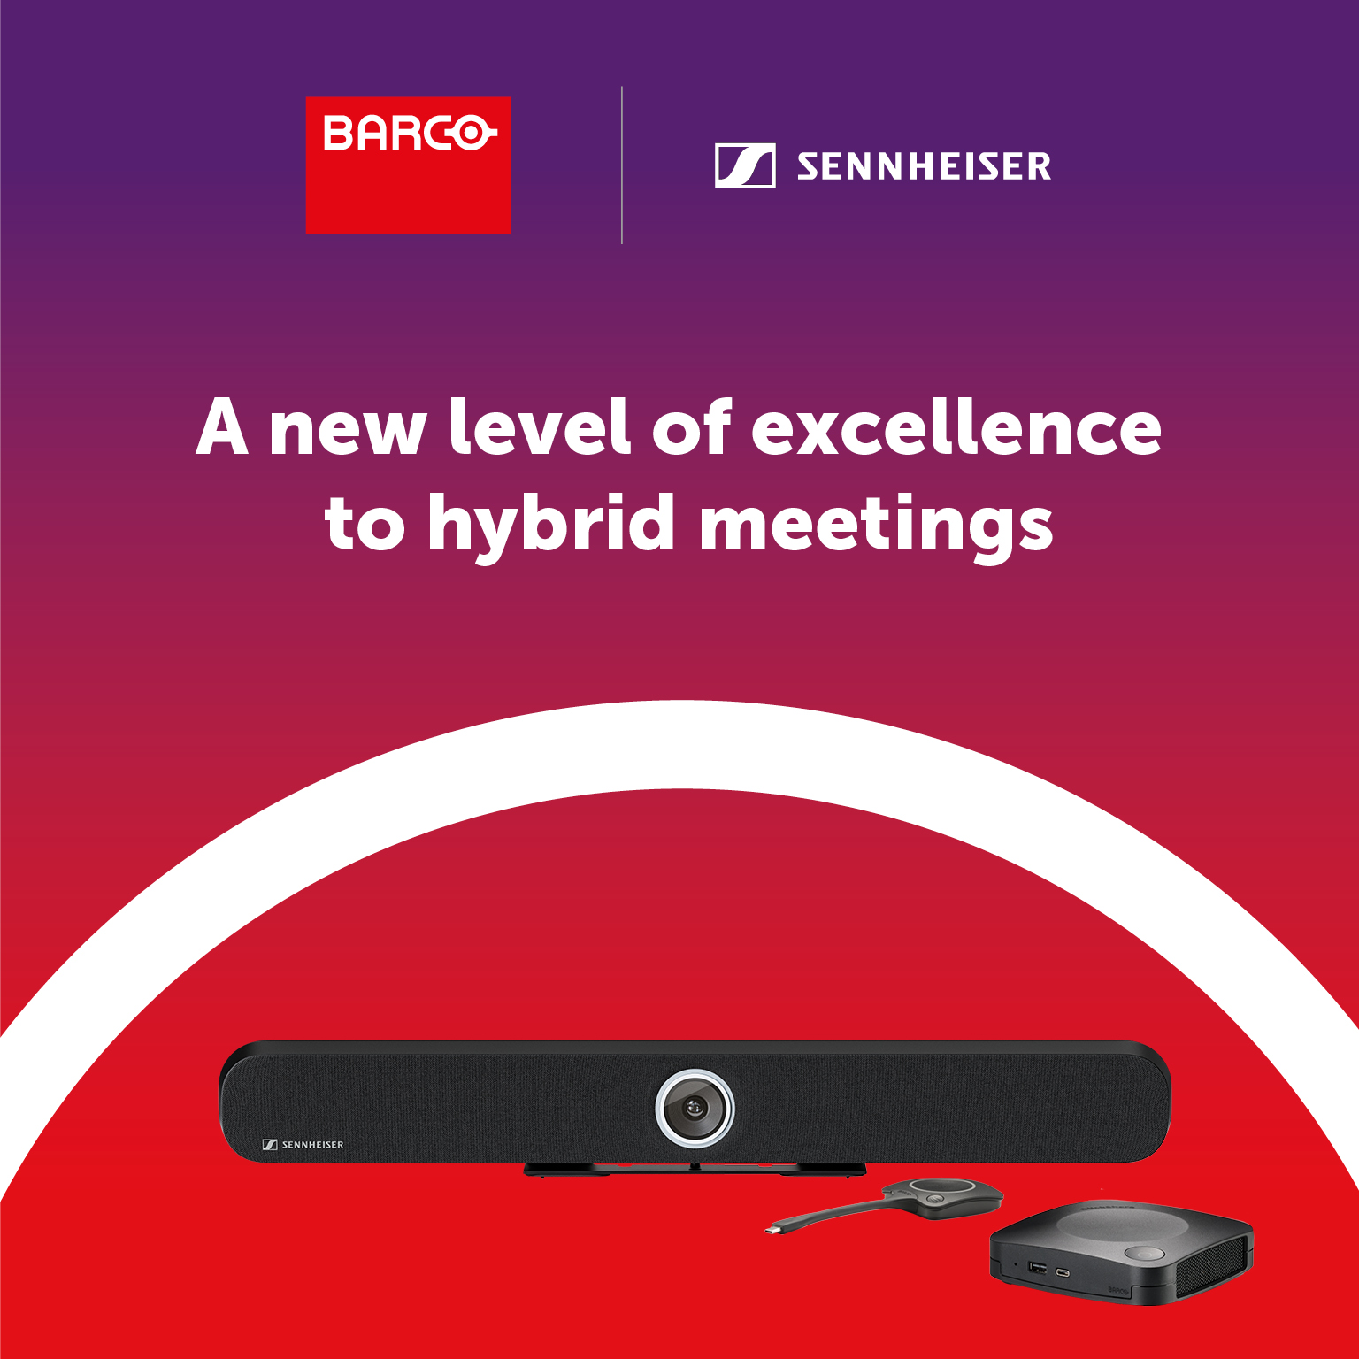

**Sennheiser and Barco Expand Popular TeamConnect Bar & ClickShare Try and Buy Program to the United States**

***Following the success of the program in Europe, institutions and organisations in the US can now benefit from the Barco Try & Buy Program***

**Old Lyme, Conn. — May 8, 2025 —** [**Sennheiser**](http://www.sennheiser.com)**, the first choice for advanced audio technology that makes collaboration and learning easier, today announced the expanded availability of its TeamConnect (TC) Bar Solutions via the Barco Try and Buy program for end user customers in the United States. As has been the case for customers in Europe since October of last year, customers in the US can now loan a Barco Clickshare solution with a TC Bar S or TC Bar M free of charge for a 30-day period.**

Sennheiser’s TC Bar Solutions (TC Bar S and TC Bar M) integrate effortlessly with Barco ClickShare Conference for a consistent, intuitive experience. Best-in-class audio ensures clear conversations, and patented beamforming technology delivers smooth presenter transitions. The Dante port allows mic extension and flexible space configuration, while 4K AI-enhanced video optimizes every detail for remote participants. Multiple mounting options simplify integration into any space and the certified integration with Barco ClickShare ensures a smooth setup process.

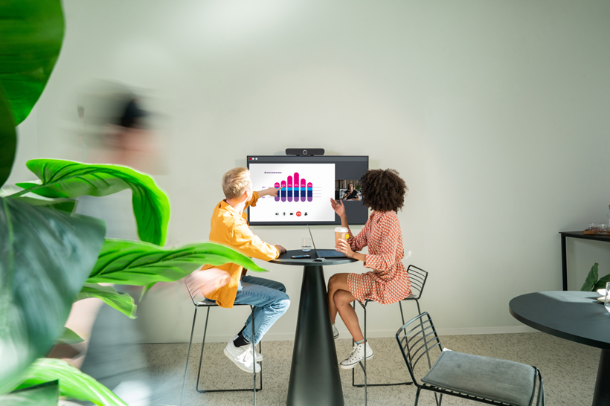

*Sennheiser’s TC Bar Solutions will be added to the Barco Try and Buy program for end user customers in the US*

ClickShare enables instant meeting starts and easy content sharing, leveraging the TC Bar to create a user-friendly environment, where technology discreetly enhances the flow of discussion. ClickShare Conference simplifies wireless collaboration, and when paired with Sennheiser's all-in-one video bars, it creates organized environments free from clutter that lead to impactful meeting experiences.

*Sennheiser’s TC Bar Solutions (TC Bar S and TC Bar M) integrate effortlessly with Barco ClickShare Conference for a consistent, intuitive experience*

“We’re extremely pleased with the reception from customers following the inclusion of our TC Bar Solutions in the Barco Try & Buy Program in Europe,” said Charlie Jones, Global Partner Relations Manager for Sennheiser. “When customers are given the opportunity to use our TC Bars with Barco Clickshare, they realize the benefits immediately. With the expansion of the program, customers in the US will now get to experience intuitive meeting environments with high quality audio and video risk free.”

*ClickShare Conference simplifies wireless collaboration, and when paired with Sennheiser's all-in-one video bars, it creates organized and clutter-free environments, leading to impactful meeting experiences*

"Our partnership with Sennheiser reflects a shared dedication to delivering an outstanding user experience in the hybrid workplace," said Dan Root, Head of Global Strategic Alliances at Barco ClickShare. "We are proud to announce the expansion of the Try & Buy Program into the US, enabling companies to easily experience a simple yet premium video collaboration solution."

To participate in the Barco Try and Buy program, customers can complete a request form via Barco’s Website: [TC Bar S & CX-30 Try & Buy](https://eur03.safelinks.protection.outlook.com/?url=https%3A%2F%2Fbarco.com%2Fen%2Fproduct%2Fsennheiser-tc-bar-s-clickshare-cx-30-bundle&data=05%7C02%7CErica.Whittle%40sennheiser.com%7C42a098c045924a045df808dce77b3d68%7C1c939853ca0f479295978519b4d0dfe3%7C0%7C0%7C638639763754168137%7CUnknown%7CTWFpbGZsb3d8eyJWIjoiMC4wLjAwMDAiLCJQIjoiV2luMzIiLCJBTiI6Ik1haWwiLCJXVCI6Mn0%3D%7C0%7C%7C%7C&sdata=rusjZDjtPOl%2Bt1T6ApKzKrjk2tdLoqIs%2BpgeEhLL0pg%3D&reserved=0),  [TC Bar M & ClickShare CX-30 Try & Buy](https://eur03.safelinks.protection.outlook.com/?url=https%3A%2F%2Fbarco.com%2Fen%2Fproduct%2Fsennheiser-tc-bar-m-clickshare-cx-30-bundle&data=05%7C02%7CErica.Whittle%40sennheiser.com%7C42a098c045924a045df808dce77b3d68%7C1c939853ca0f479295978519b4d0dfe3%7C0%7C0%7C638639763754192185%7CUnknown%7CTWFpbGZsb3d8eyJWIjoiMC4wLjAwMDAiLCJQIjoiV2luMzIiLCJBTiI6Ik1haWwiLCJXVCI6Mn0%3D%7C0%7C%7C%7C&sdata=hS6bmyKGYYFFufu0Wj7nCM9zAq332g93iP8INLciwrs%3D&reserved=0). For more information about the Sennheiser and Barco partnership, visit <https://www.sennheiser.com/en-us/global-cooperation/barco>.

###

**About the Sennheiser brand**

We live and breathe audio. We are driven by the passion to create audio solutions that make a difference. Building the future of audio and bringing remarkable sound experiences to our customers – this is what the Sennheiser brand has represented for more than 75 years. While professional audio solutions such as microphones, meeting solutions, streaming technologies and monitoring systems are part of the business of Sennheiser electronic SE & Co. KG, the business with consumer devices such as headphones, soundbars and speech-enhanced hearables is operated by Sonova Holding AG under the license of Sennheiser.

[www.sennheiser.com](http://www.sennheiser.com)

[www.sennheiser-hearing.com](http://www.sennheiser-hearing.com)

**Global Press Contact**

Jeffrey Horan

Global PR/Media Manager Business Communication

[jeffrey.horan@sennheiser.com](mailto:jeffrey.horan@sennheiser.com)

[+1 860-598-7539](tel:+1%20860-598-7539)